Communication in Organizations

1. Formal Communication (Communication defined by the company policy)
   1. Horizontal

Executive Director

GM.............

GM (Production)

GM ( Human Resource )

GM (Marketing)

DGM .......

DGM (S)

DGM (N)

Senior Manager

Senior Manager

Senior Manager

Senior Executive

Senior Executive

Junior Executive

Junior Executive

Junior Executive

Red Arrow – Horizontal Communication

Green Arrow – Downward Communication

Yellow Arrow – Upward Communication

Blue Arrow – Diagonal Communication

THE ABOVE IS CALLED THE HIERARCHY OF THE ORGANIZATION ( NOT ALL LEVELS ARE SHOWN)

Horizontal Communication – This communication takes place at the same level of the organization. Thus if all the GM’s are communicating with each other or they are a part of a team dealing with new product launch – Then it will be horizontal communication. Formal Communication channels are defined by the company and everyone must follow strictly follow whatever is defined.

* 1. 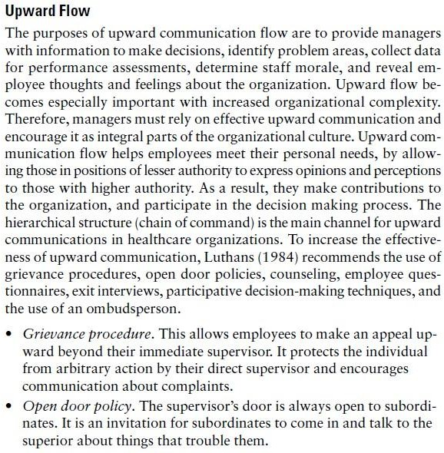Vertical (Upward / Downward)

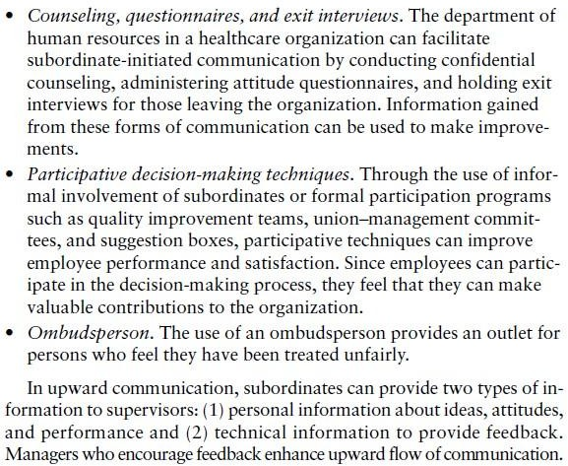

* 1. Diagonal

Interdepartmental Communication is called Diagonal communication. This communication takes place between different levels of the organization.

1. Communication Networks

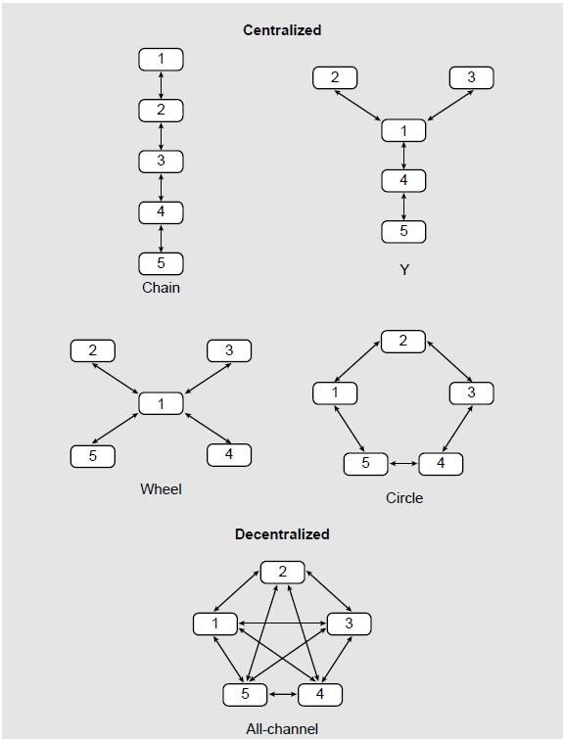The pattern of communication is called Communication Network. The entities shown are people. Thus in case of Chain Pattern 5 communicates with 4 and 4 with 3. There is no direct communication between 5 and 1. The communication takes place in a chain. Similarly for other patterns.

1. Informal Communication (relationship based)

Informal Communication is that communication which is not formal. Thus there could be a group of people at different levels or same level who have graduated from the same institute. These people will have affiliation because of the parent education institute. These people, if they communicate, will not follow the formal channels but will have an informal channel. Informal channel can protect and guide you. If you and the boss of your boss play Golf together then you can form a bond and hence communicate outside the formal channels. It is not necessary that informal channel is based on affiliation alone.Informal channel can also have a pattern. Let us talk about the Probability pattern as given below. (Informal channel is relationship based)

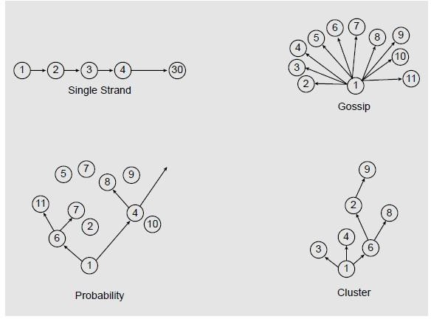

In probability pattern some news is being passed to the colleagues ( or people in the office) and this is a type of “Breaking news”. The person shown as 1 in the pattern has come to know about something through his / her own informal channel ( some friend in the head office). The news concerns the probability of a departmental head ( in the office where this communication is taking place) leaving the organization. 1 passes on this news to 6 and 6 to 7. 2 is left out and not informed and so on.

1. Communication with stakeholders external to the organization (EXTERNAL ENTITIES)
   1. Media: The organization communicates with the media when new products are to be launched. The org must give clear instructions to the media regarding the target market i.e on whom the product must focus. The media is basically the advertising agency that is handling the companies account and gets paid for designing the advertisement / placing the advertisement in the correct slot at the best price so that the companies product gets widespread audience.(Also Event Management agency)
   2. Vendors : The vendors supply the material to the organization. The org makes a number of products ( Maruti) or P&G (consumer product like soap , oil, washing powder) or a single product ( may be one machine). Each machine / product requires a number of ingredients and hence there are many vendors supplying different products / ingredients that the org Assembles or processes. The org must communicate to the vendor about the production schedule so that input material is available on the assembly line on time. The vendor must adhere to quality as required by the org and the org must pay the vendor for the material.
   3. Apex organizations protect the interests of the org. All organizations in a particular line of business are members of an apex org in that field like Cement manufacturers association of India, Tractor manufacturers association of India etc. The apex organization negotiates with the Govt regarding tax exemption, tax holidays, excise rebate etc.
   4. Society

ALSO IN CASE OF CORPORATE SOCIAL RESPONSIBILITY (What the company is doing)

Sometimes the organization must communicate with the society ( consumers) directly. This

happened during Maggi court case. The company Nestle clarified in press that Maggi is

perfectly safe to eat.

* 1. Transporters - The company must communicate with the transporters who carry the goods of the organization till the destination. The transporters can be contract carriers of private carriers or company owned.
  2. Insurance Providers -The organization must communicate with Insurance providers to

insure the goods in transit. Thus the goods can be FOR Company stockyard or FOR Factory. FOR (Free on Road) company stockyard means the company will insure the goods till its stockyard. Thus is Maruti cars are coming from Gurugram to Maruti stockyard in Chandigarh then the goods will be insured till the Chandigarh stockyard. From that stockyard it is the responsibility of the dealer. The company must negotiate with the Insurance providers about the premium.

* 1. Consumers- The company can communicate with consumers directly. This can be to get the feedback about the product. The customer contact center also can be approached in case of a problem.
  2. Wholesalers / retailers / dealers – The company must communicate with the these entities to deliver the product to the ultimate consumer. The wholesaler / retailer / dealer carry the company product line.
  3. Legal entities – courts : The company must communicate with the courts ( consumer) and others. The company must defend itself against a complaint in consumer court and they must go to court if they wish to sue another company for copyright / patent infringement.
  4. R&D / Technology Providers- The company must communicate with them to finalize the deal.
  5. Banks – Banks provide loans to the organization and also sometimes underwrite the share issue. Underwrite means the bank will buy unsold shares.
  6. Government – The company needs to communicate with the government regarding filing of IT , Excise returns and also related to GST. The company also needs to adhere to pollution norms set by the government. (work-from-home)
  7. Quality certification authority– The company needs to apply for certification for ISO 9000 etc and hence needs to communicate with quality certification authority.
  8. Patent office- If the company wants to protect its Intellectual Property its needs to file for a Patent in the Patent office. Also Designs ( external appearance of the product ), Trademarks (logo etc) and Copyrights (written material ) can be protected.
  9. Outsourcing service providers- The company needs to outsource some of its activities and hence needs to outsource its activities. Activities like billing, customer contact can be outsourced. India’s IT companies like Infosys and TCS handle this type of business for foreign clients.
  10. Owners / shareholders- The company needs to communicate with owners and shareholders in order to inform them about the how business is performing. The owners have invested money in the company in the form of capital and the shareholders have invested in equity.

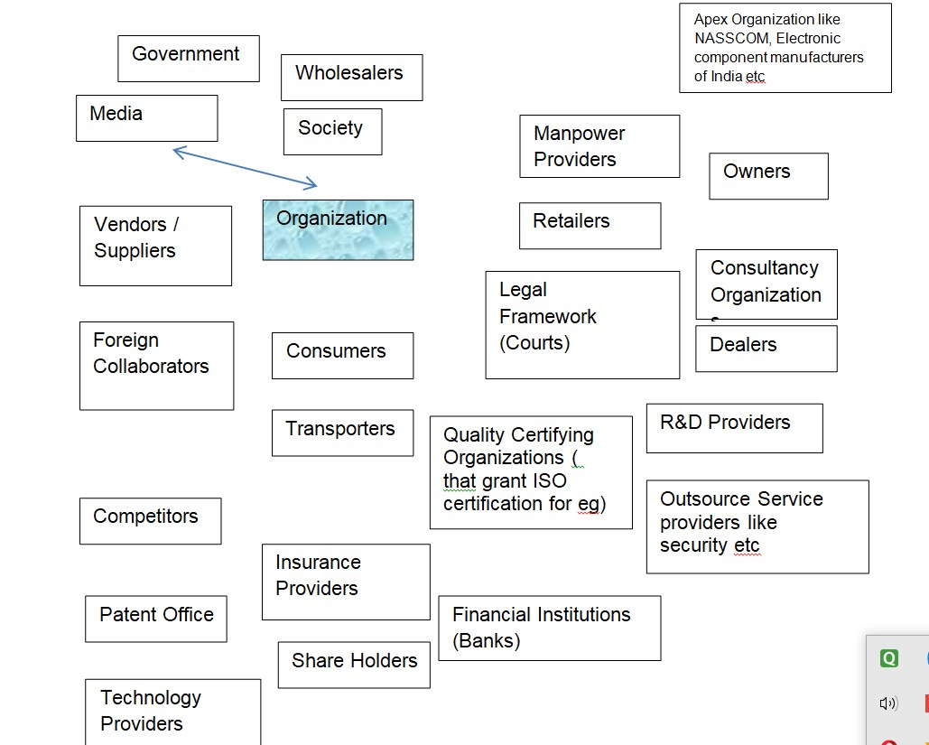

FOR A PRODUCT BASED COMPANY – PHARMA COMPANY , MARUTI , NESTLE ETC